1.
#pragma warning (disable: 4996)
#include<stdio.h>
int main() {
int p , i ;
char flag = 0;
scanf ( "%d" , & p );
for ( i = 2; i * i < p; ++i)
if (p % i == 0) {
printf ( "%d %d ", i, p / i) ;
flag = 1;
}
if (i* i == p) {
printf("%d ", i);
flag = 1;
}
if (flag == 0) printf("%d", p);
return 0;
}
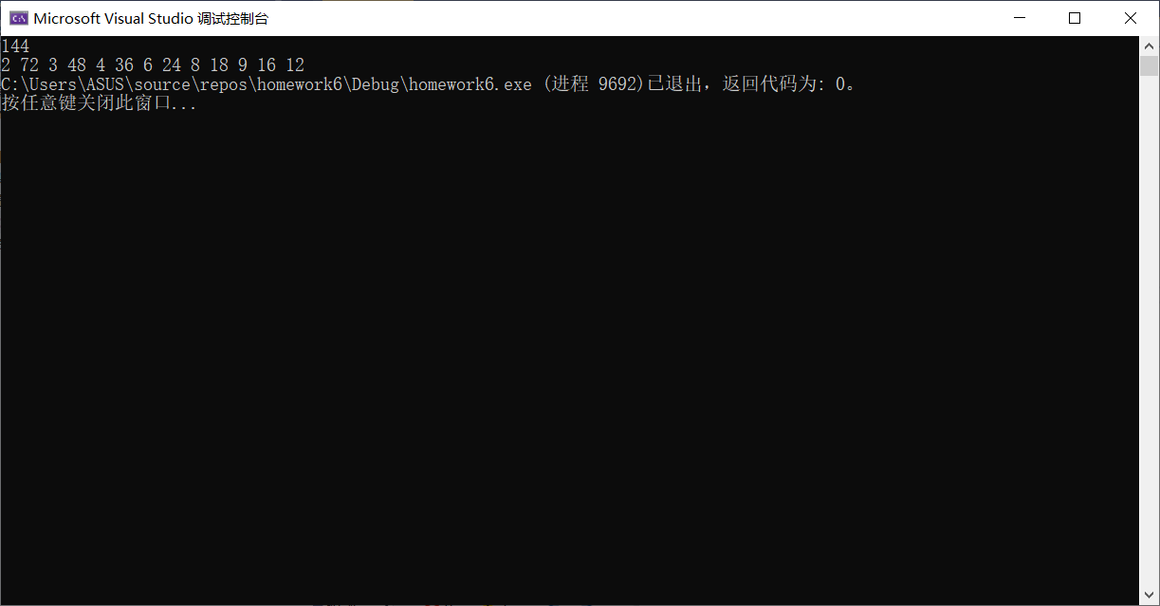

3.
#pragma warning(disable: 4996)
#include<stdio.h>
#include<math.h>
int main() {
double S = 1.0, term = 1, x ;
int i = 1;
scanf("%lf", &x);
do {
term *= (0.5 - i + 1) * x / i;
S += term;
++i;
} while (fabs(term) >= 0.000001);
printf("%lf", S);
return 0;
}
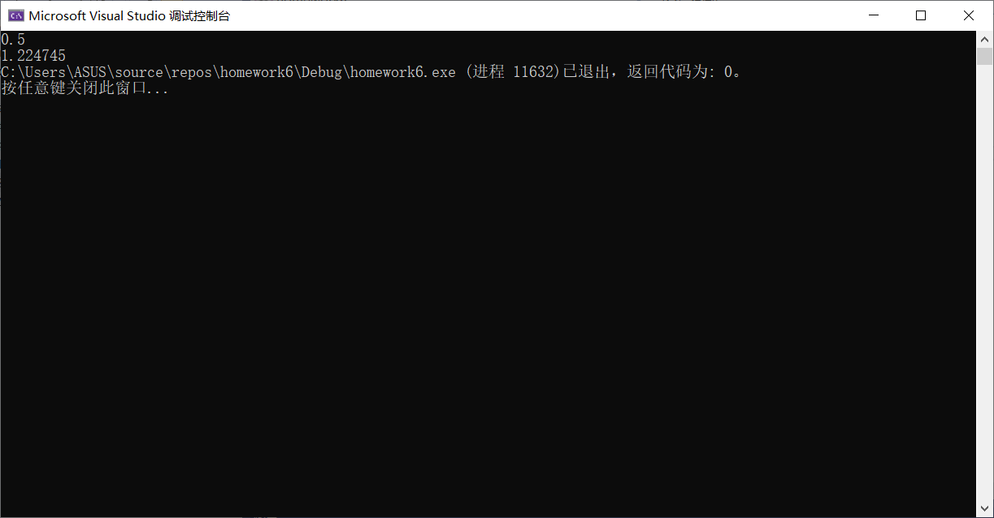

4.
#pragma warning(disable:4996)
#include<stdio.h>
int main() {
double s = 0.0;
int fb1 = 0, fb2 = 1, term = 1 , n ;
scanf("%d", &n);
for (int i = 0; i < n; ++i) {
int tmp = fb2;
fb2 += fb1;
fb1 = tmp;
s += (double)fb2 / fb1;
}
printf("%lf", s);
return 0;
}
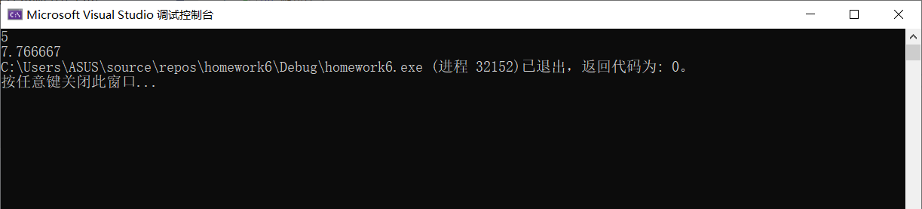
7.
#pragma warning(disable:4996)
#include<stdio.h>
#include<math.h>
int main() {
double x, sumOfPositive = 0.0 , sumOfNegative = 0.0 , sumOfAbs = 0.0 ;
int numOfPositive = 0, numOfNegative = 0;
for (int i = 0; i < 30; ++i) {
scanf("%lf", &x);
sumOfAbs += fabs(x);
if (x > 0) {
sumOfPositive += x;
++numOfPositive;
}
else if (x < 0) {
sumOfNegative += x;
++numOfNegative;
}
}
printf("The sum of positive numbers is %lf.\nThe sum of negative numbers is %lf.\nThe sum of the absolute value is %lf.\n", sumOfPositive, sumOfNegative, sumOfAbs);
printf("The number of positive numbers is %d.\nThe number of negative numbers is %d.\n", numOfPositive, numOfNegative);
return 0;
}
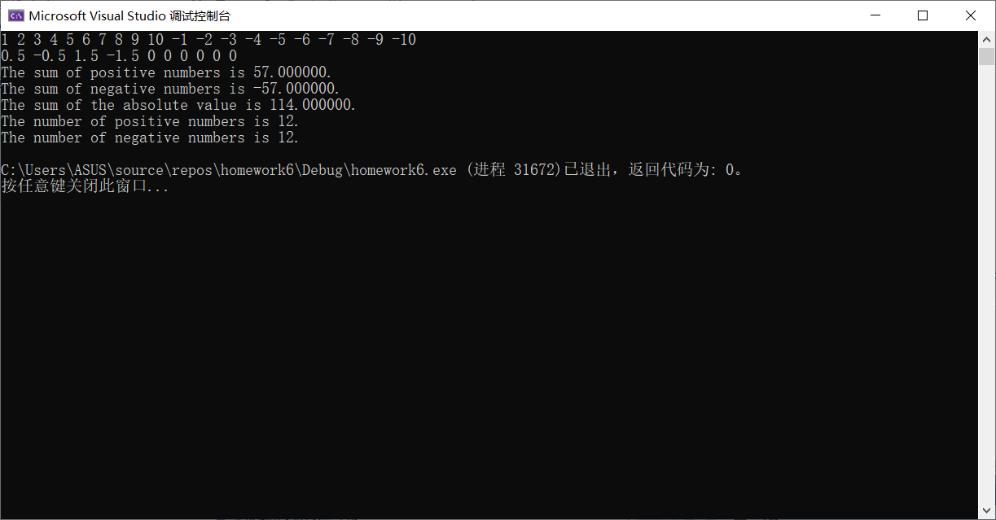

10.
NS图：
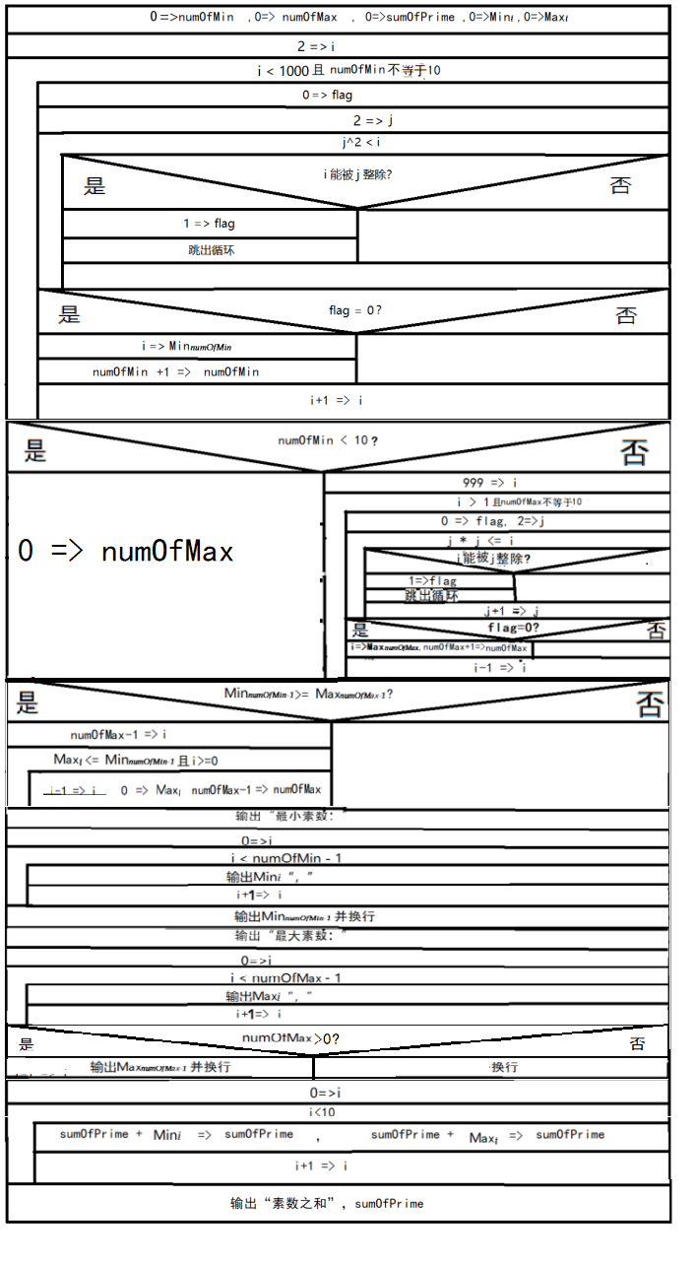
#pragma warning(disable:4996)
#include <stdio.h>
#define NUMBER 20
int main() {
int numOfMin = 0 , numOfMax = 0 , sumOfPrime = 0 ;
int Min[10] = { 0 }, Max[10] = { 0 };

//Find the minimum 10 primes.

for (int i = 2; i < NUMBER; ++i) {
int flag = 0;
for (int j = 2; j * j <= i; ++j) {
if (i % j == 0) {
flag = 1;
break;
}
}
if (flag == 0) {
Min[numOfMin] = i;
++numOfMin;
}
if (numOfMin == 10) break;
}

//Not exists 10 primes.

if (numOfMin < 10) {
numOfMax = 0;
}
else {

//Find the maximum 10 primes.

for (int i = NUMBER - 1; i >1; --i) {
int flag = 0;
for (int j = 2; j * j <= i; ++j) {
if (i % j == 0) {
flag = 1;
break;
}
}
if (flag == 0) {
Max[numOfMax] = i;
++numOfMax;
}
if (numOfMax == 10) break;
}
}
//去除重复。

if (Min[numOfMin - 1] >= Max[numOfMax - 1]) {
int i = numOfMax - 1;
while (Max[i] <= Min[numOfMin - 1] && i >= 0) {
Max[i] = 0;
--numOfMax;
--i;
}
}
for (int i = 0; i < 10; ++i) {
sumOfPrime += Min[i];
sumOfPrime += Max[i];
}

//Output the 20 primes.

printf("最小素数:");
for (int i = 0; i < numOfMin - 1; ++i) printf("%d,", Min[i]);
printf("%d\n", Min[numOfMin - 1]);
printf("最大素数:");
for (int i = 0; i < numOfMax - 1; ++i) printf("%d,", Max[i]);
if(numOfMax > 0) printf("%d\n", Max[numOfMax - 1]);
printf("\n");
printf("素数之和:%d",sumOfPrime);
return 0;
}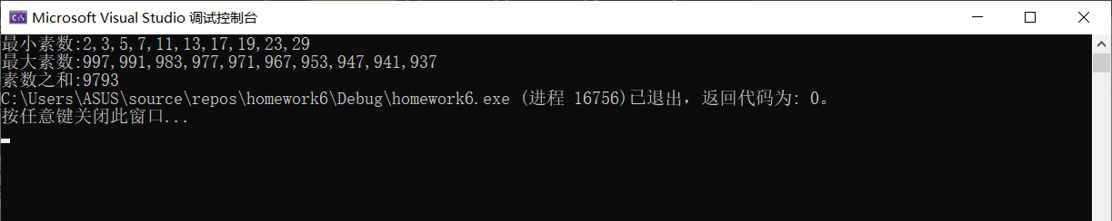

11.
NS图：

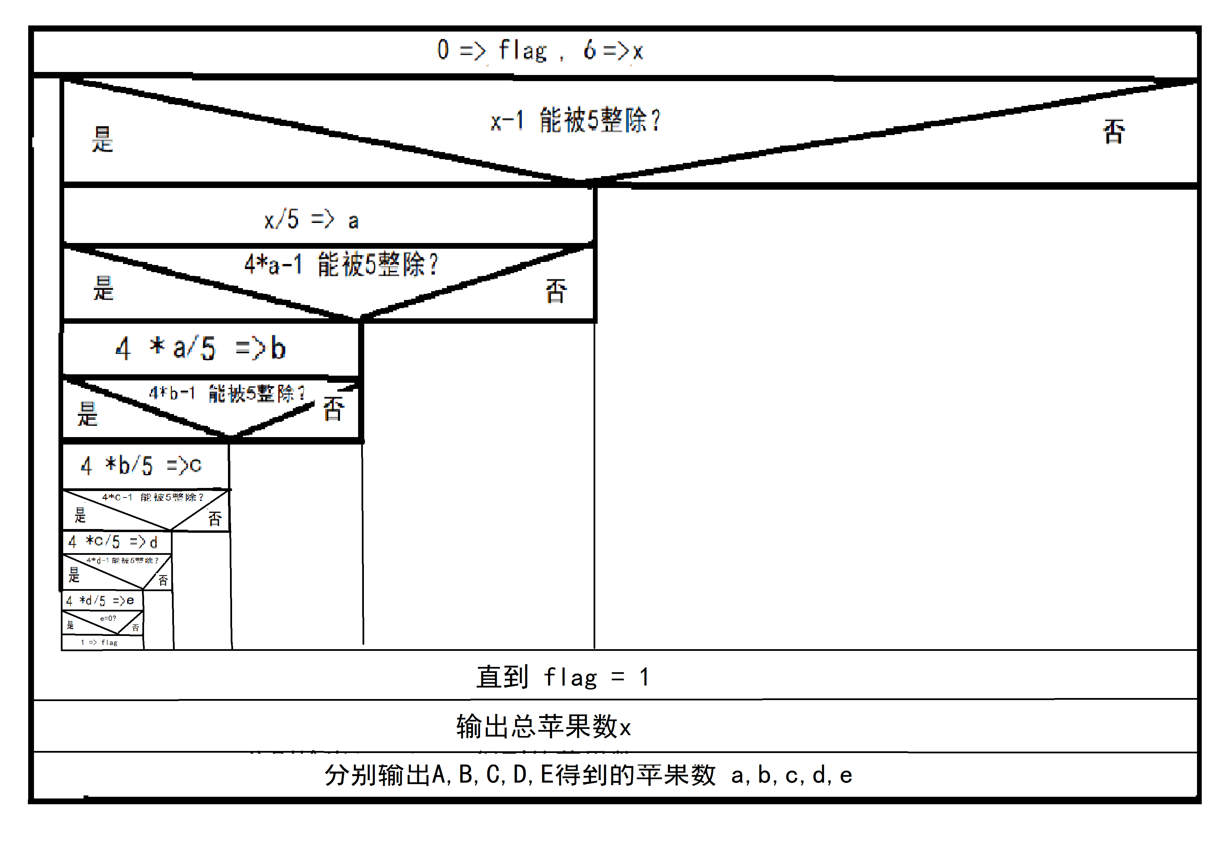

#pragma warning(disable:4996)
#include<stdio.h>
int main() {
int a, b, c, d, e, x = 6, flag = 0;
do {
if ((x - 1) % 5 == 0) { //判断A是否可分
a = x / 5; //个人认为不必用书中的x-1，因为商始终取整
if ((4 * a - 1) % 5 == 0) { //判断B是否可分
b = 4 * a / 5; //个人认为不必用书中的4*a-1，因为商始终取整，下同
if ((4 * b - 1) % 5 == 0) { //判断C是否可分
c = 4 * b / 5;
if ((4 * c - 1) % 5 == 0) { 判断D是否可分
d = 4 * c / 5;
if ((4 * d - 1) % 5 == 0) { //判断E是否可分
e = 4 * d / 5;
if (e > 0) flag = 1; //判断E是否分到0个
}
}
}
}
}
++x;
} while (flag == 0);
--x;
printf("The number of the apples is initially at least %d.\n", x);
printf("The numbers of the apples that each person gets are:\nA:%d\nB:%d\nC:%d\nD:%d\nE:%d\n", a, b, c, d, e);
return 0;
}
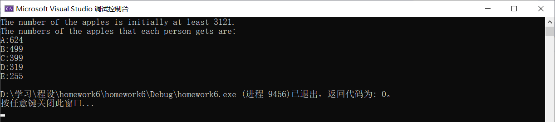

12.
#include <stdio.h>
int main() {
char a , b , c , d , e , f ;
for ( a = 0 ; a < 2 ; ++a )
for ( b = 0 ; b < 2 ; ++b )
for ( c = 0 ; c < 2 ; ++c )
for ( d = 0 ; d < 2 ; ++d )
for ( e = 0 ; e < 2 ; ++e )
for ( f = 0 ; f < 2 ; ++f )
//If C don't go, neither do B; one of C and D will go; D and E are consistent.
if ( ( c + b == 0 || c ) && ( c + d == 1 ) && ( d + e == 2 || d + e == 0) &&
//Two of A, C and F will go; C and F can't go together; at least one of E and F will go.
a + b + f == 2 && c + f < 2 && e + f > 0 ) {
if ( a ) printf("A ") ;
if ( b ) printf("B ") ;
if ( c ) printf("C ") ;
if ( d ) printf("D ") ;
if ( e ) printf("E ") ;
if ( f ) printf("F ") ;
printf("is supposed to go.\n") ;
}
return 0 ;
}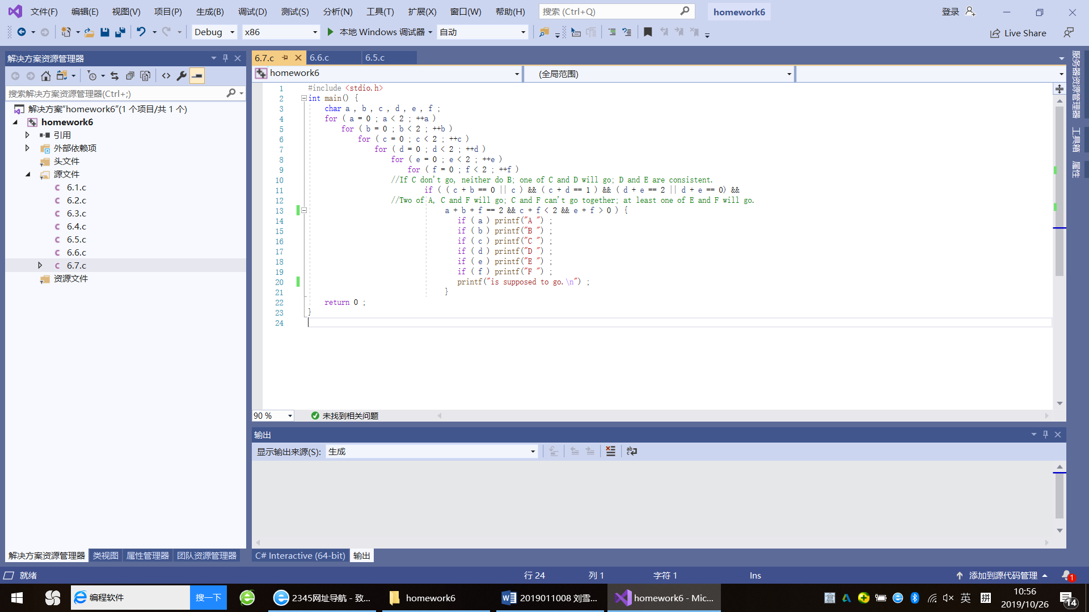
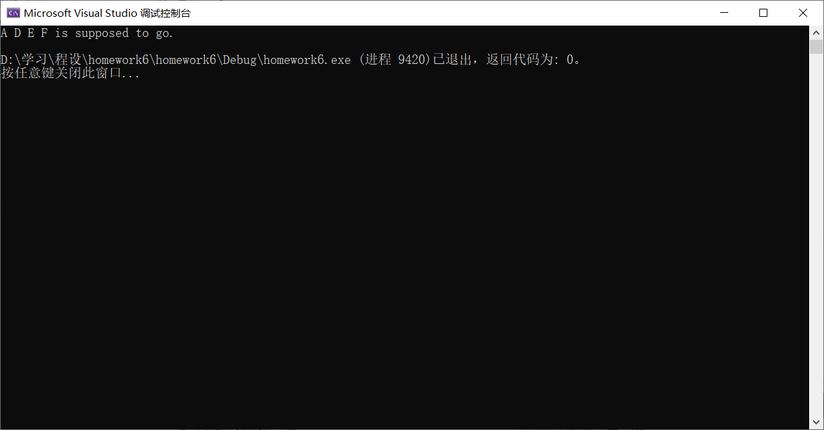

NS图：
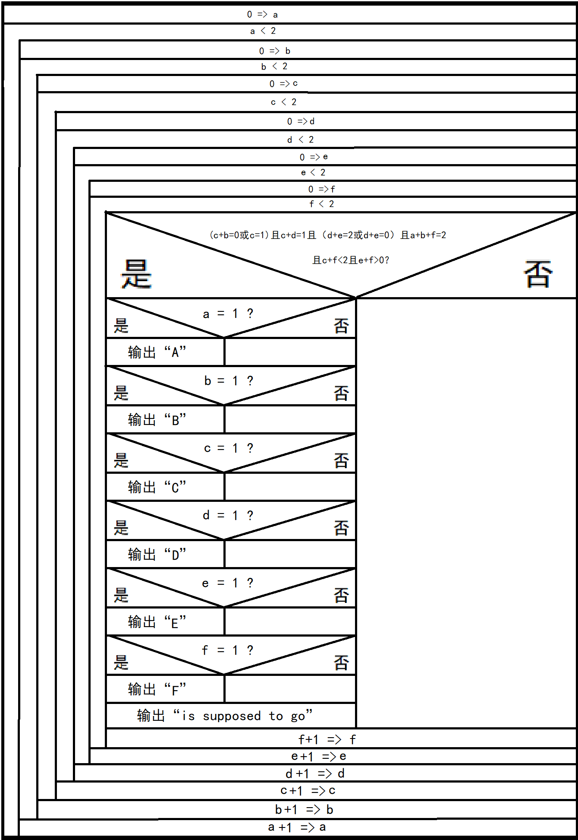

黑色星期五：
/*现行公元纪年称作格里历，而格里历是在1582年是间断的，而且1582年前是绝对的4年一闰。因此星期
与月份是有偏差的。公园元年元月元日是实际上的星期六（https://max.book118.com/html/2017/0414/100343400.shtm），
而用现在的日期按四年一闰百年不闰四百年再闰的算法计算公元元年元月元日是星期一*/

#pragma warning(disable:4996)
#include <stdio.h>
#define GREGORY 1
int main() {
int theFirstDay; //Record January 1st. 1AD.

#if GREGORY

{
//30th. March 2000 is Thursday.
int leapYears = 2000 / 4 - 2000 / 100 + 2000 / 400;
int days = (1999 - leapYears) * 365 + leapYears * 366 + 31 + 28 + 30 - 1 ;

//Calculate January 1st. 1AD is what day.

if (days % 7 <= 4) theFirstDay = 4 - days % 7;
else theFirstDay = 4 - days % 7 + 7; //This can calculate January 1st is Monday.
}

#else

theFirstDay = 6;//In fact, it is Saterday.

#endif

int year, leapYears, days, lastOfLastYear, flag;
scanf("%d", &year);
leapYears = (year-1) / 4 - (year - 1) / 100 + (year - 1) / 400;
days = leapYears * 366 + (year - 1 - leapYears) * 365;
//Calculate the last day of the year before.
lastOfLastYear = (theFirstDay + (days-1) % 7) % 7;
printf("The black Fridays in the year %d are:\n", year);
days = 0;
flag = 0;
for (int i = 1; i <= 12; ++i) {
switch (i - 1) { //Add total months.
case 0:
break;
case 1:
case 3:
case 5:
case 7:
case 8:
case 10: //Not include 12.
days += 31;
break;
case 4:
case 6:
case 9:
case 11:
days += 30;
break;
case 2:
if (year % 400 == 0 || year % 4 == 0 && year % 100) days += 29;
else days += 28;
break;
default:
printf("Error!");
return 1;
break;
}
days += 13;
if ((lastOfLastYear + days) % 7 == 5) {
flag = 1;
switch (i) {
case 1:
printf("January\n");
break;
case 2:
printf("Febrary\n");
break;
case 3:
printf("March\n");
break;
case 4:
printf("April\n");
break;
case 5:
printf("May\n");
break;
case 6:
printf("June\n");
break;
case 7:
printf("July\n");
break;
case 8:
printf("August\n");
break;
case 9:
printf("September\n");
break;
case 10:
printf("October\n");
break;
case 11:
printf("November\n");
break;
case 12:
printf("December\n");
break;
}
}
days -= 13;
}
if (flag == 0) printf("none.\n");

/*Calculate the maximal and minimal number of black Friday
a year from 0 to 2018. */

int max = -1, min = 13;
for (int i = 1; i <= 2019; ++i) {
int leapYears, days, lastOfLastYear, flag;
leapYears = (i-1) / 4 - (i - 1) / 100 + (i - 1) / 400;
days = leapYears * 366 + (i - 1 - leapYears) * 365;
lastOfLastYear = (theFirstDay + (days - 1) % 7) % 7;
days = 0;
flag = 0;
for (int j = 1; j <= 12; ++j) {
switch (j - 1) { //Add total months.
case 0:
break;
case 1:
case 3:
case 5:
case 7:
case 8:
case 10: //Not include 12.
days += 31;
break;
case 4:
case 6:
case 9:
case 11:
days += 30;
break;
case 2:
if (i % 400 == 0 || i % 4 == 0 && i % 100) days += 29;
else days += 28;
break;
}
days += 13;
if ((lastOfLastYear + days) % 7 == 5) ++flag;
days -= 13;
}
if (max < flag) max = flag;
if (min > flag) min = flag;
}
printf("\nThe maximal number of black Fridays a year from 1 to 2019 has is %d.\n", max);
printf("The minimal number of black Fridays a year from 1 to 2019 has is %d.\n", min);
return 0;
}

//If GREGORY is defined 1, we will get:
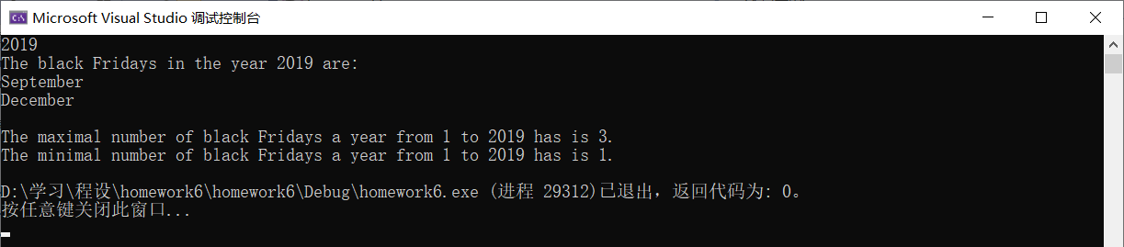
//It is accurate when the input number is bigger than 1582.
//但是，如果GREGORY被定义为0， 那么：
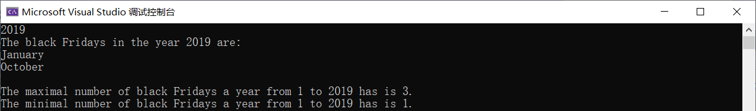
//这显然是不对的，但这在公元1~3年是准确的！！！

